

Assessment Cover Page
Student Full Name
Nergui Batbayar
Student Number
2026793
Module Title
Statistical techniquies for data

Assessment Title
CA1
Lecturer/Supervisor
Taufigue Ahmed
Assessment Due Date
01/11/2026
Date of Submission
04/11/2026
Use of AI Tools
I used ChatGPT to help structure this report, edit the text, translate between Mongolian and English, and understand statistical concepts and Python code. I also received assistance in interpreting and understanding the descriptive statistics and the results of calculations involving the Binomial, Poisson and Normal distributions. I reviewed and revised the AI-assisted content and checked the results presented in the report against my Jupyter Notebook. I take full responsibility for the final work submitted.

Declaration
By submitting this assessment, I confirm that I have read the CCT policy on academic misconduct and understand the implications of submitting work that is not my own or does not appropriately reference material taken from a third party or other source.
I declare it to be my own work and that all material from third parties has been appropriately referenced.
I further confirm that this work has not previously been submitted for assessment by myself or someone else in CCT College Dublin or any other higher education institution.

Contents

1. Assessment Title……………………………………………………………………………………………………………1
2. Introduction and dataset…………………………………………………………………………………………….…1

3. Data preparation and descriptive statistics .………………………………………………………………2-3
4. Binomial distribution …………….…………………………………………………………………..…………………4
5. Poisson distribution ……………………………………………………………………………………………………..5
6. Normal distribution ……………………………………………………………………………………………………..6
7. Comparison and conclusion ………………………………………………………………………………………….7

1 Assessment Title
Statistical Analysis of Road Collisions in Grear Britan in 2025

2 Introduction and dataset

This report examines road collisions recorded in Great Britain in 2025 using descriptive statistics and probability distributions. It considers how collision severity is distributed, how daily collision counts vary, and what Binomial, Poisson and Normal models can explain. The analysis focuses on describing recorded collisions rather than estimating the risk of being involved in a collision on an individual journey. The main finding is that model suitability depends on the variable and the research question; the same distribution is not appropriate for every numerical column. The collision dataset contains 101,525 rows and 44 columns. Each row represents one collision on a public road. Unreported collisions and damage-only collisions are not included in this dataset (Department for Transport, 2026). The file was saved locally as road-2025.csv. Collision severity and day of the week are categorical variables, although they are coded as numbers. Vehicle count and casualty count—the number of people injured or killed—are numerical variables. A third numerical measure, daily collision count, was derived by grouping records by date, with one day as its observational unit. The analysis was conducted in Jupyter Notebook using Pandas for data processing, NumPy for numerical operations, Matplotlib and Seaborn for charts, and SciPy for probability calculations. Descriptive statistics were calculated before selecting the probability models. The report links each model to a specific question and presents the estimated parameters and the probabilities calculated from them. This makes the calculations reproducible and distinguishes model assumptions from the proportions observed in the data.

3. Data preparation and descriptive statistics

Python checks examined shape, column types, missing values, duplicated rows and duplicated collision identifiers. No complete duplicate rows or repeated identifiers were found. Four coordinate fields each contained two missing entries; these are not necessarily eight different collisions. They were retained because coordinates were not needed for these calculations. Numeric codes elsewhere should not automatically be treated as measurements or as complete information. Dates were converted from day/month/year text before daily aggregation. All 365 calendar days were represented nationally.

Table 1 Numerical summaries at collision and day levels
Measure | Vehicles per collision | Casualties per collision | Collisions per day
Count | 101,525 | 101,525 | 365
Mean | 1.81 | 1.26 | 278.15
Median | 2 | 1 | 279
Sample SD | 0.69 | 0.82 | 52.47
Minimum | 1 | 1 | 120
Q1 | 1 | 1 | 243
Q3 | 2 | 1 | 311
Maxmum | 17 | 142 | 412

Table 1 summarises the numerical variables. The number of vehicles involved per collision has a mean of 1.81 and a median of 2, with the middle 50% of observations between one and two vehicles. The histogram shows that two-vehicle collisions are the most frequent, while the right tail extends to 17. The mean can be lower than the median because many collisions involve only one vehicle; this does not contradict the presence of a right tail. The interquartile range (IQR) is 1, giving an upper outlier fence of 3.5. Therefore, 1,939 collisions involving four or more vehicles, representing 1.91% of all collisions, were flagged as outliers. These unusual values were retained in the analysis rather than automatically treated as errors. The number of casualties per collision has a mean of 1.26, a median of 1 and a maximum of 142. At least 75% of records contain one casualty. A small number of high values raise the mean above the median. The record involving 142 casualties was inspected and retained, but its presence alone neither establishes a data error nor confirms that it has been verified against an independent source. “Casualties” includes both injured and killed people, so this value must not be interpreted as
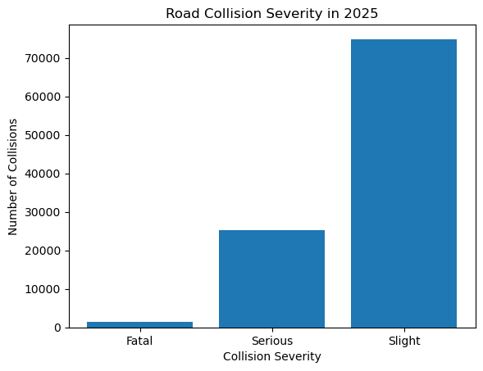Figure 1 Severity frequencies calculated from the 2025 collision records
Figure 1 shows 74,881 slight collisions (73.76%), 25,191 serious collisions (24.81%) and 1,453 fatal collisions (1.43%). A bar chart suits these separate categories. The histogram and boxplot in Figure 2 reveal concentration, spread and unusual vehicle counts. Together, these displays provide more information than a mean alone. National weekday totals are highest on Friday and lowest on Sunday. Counts do not measure exposure-adjusted risk, and weekday totals are also affected slightly by the number of occurrences of each weekday in the year.
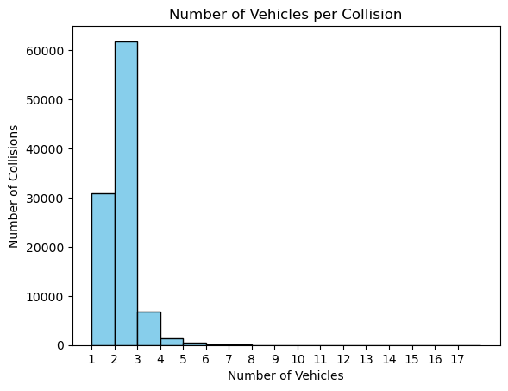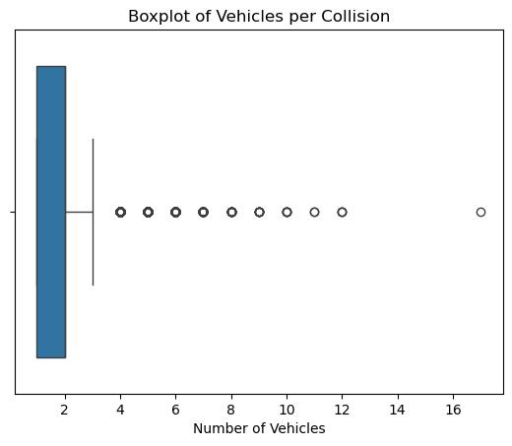
Figur 2 Vehicle count histogram and boxplot with unusual observation retained.

4. Binomial distribution

The Binomial distribution is used to address the following question: what is the probability that exactly three out of ten randomly selected collision records involve a fatal or serious collision? Here, “success” is a mathematical term referring to these two categories and does not imply a positive outcome. There are 26,644 collisions in these categories, giving p = 26,644 / 101,525 = 0.262438. The calculation uses the formula P(X = k) = C(n,k) p^k (1−p)^(n−k), with n = 10 and k = 3, implemented using the binom.pmf() function (SciPy community, n.d.a). The result is 0.257544, or 25.75%. This differs from 26.24%, which is the probability that a single selected record belongs to either of these two categories. This model assumes a fixed number of trials, two possible outcomes, independent selections and a constant probability of “success”. Random sampling with replacement from the recorded dataset satisfies these conditions. However, if ten different records are selected without replacement, the selections are dependent, so the Binomial distribution provides an approximation. Nevertheless, the sampling fraction is very small relative to the full dataset. This overall proportion also masks differences between locations, road conditions and dates. Therefore, it should not be interpreted as a probability that applies equally to all future collisions. Figure 3 shows the theoretical probabilities, while the simulation in the Notebook repeatedly generates artificial outcomes using the calculated value of p.
P=severe.mean()
probability = binom.pmf(3, 10, p)
Print(probability*100)

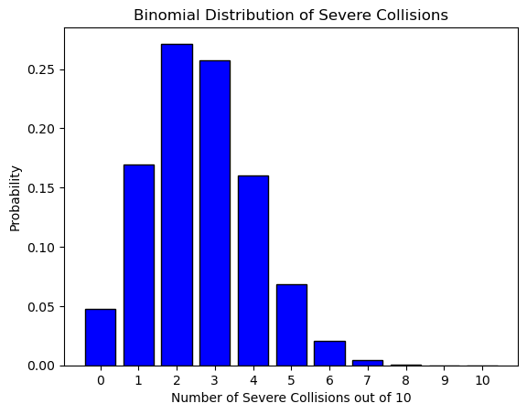
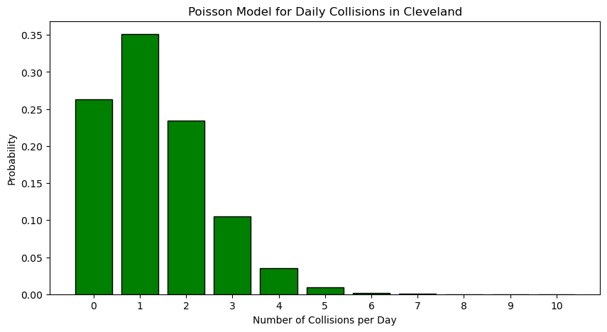

Figur 3 Theoretical Binomial and Poisson probabilities fordifferent questions.

5 . Poisson distribution
The Poisson distribution is used to examine the probability of exactly two collisions being recorded in Cleveland in one day. Cleveland, identified by police force code 17, was selected after an initial exploration of daily collision counts across regions. Therefore, this is an illustrative subgroup analysis rather than a pre-planned confirmatory analysis. The 488 collisions recorded in this area give lambda = 488 / 365 = 1.336986, representing an average of 1.336986 collisions per calendar day. Dividing by all 365 days includes days with no recorded collisions. Using the formula P(X = k) = exp(−lambda) lambda^k / k!, implemented through poisson.pmf(2, lambda), gives a probability of 23.47% (SciPy community, n.d.c). In the observed data, exactly two collisions were recorded on 22.19% of days, compared with the modelled probability of 23.47%, a difference of 1.28 percentage points. Agreement for this particular count is useful, but it does not establish that the model fits the observed data across the full distribution. Nationally, the mean daily collision count is 278.15 and the variance is 2,753.07, indicating substantially greater variability than a constant-rate Poisson model allows. Restricting the geographical coverage reduces the mixing of data from different regions, but this alone does not establish model suitability. The Cleveland calculation still assumes that collisions occur independently and at a constant rate. Differences in weekdays, seasons and traffic levels may violate these assumptions. Therefore, this model is an approximation based on specific assumptions, rather than a prediction validated for operational use.
lambda_rate=len(region)/365
Poission_probability = poisson.pmf(2, lambdarate)
Print(poisson_probability*100)
Cleveland calculation | Result
Recorded collisions | 488
Calendar days | 365
Daily lambda | 1.336986
Model probability of exactly 2 | 23.47%
Observed days with exactly 2 | 81 of 365
Observed percentage | 22.19%

6. Normal distribution
Nationally, the mean daily collision count is 278.15, the median is 279, and the sample standard deviation is 52.47. Daily counts range from 120 to 442, with the middle 50% between 243 and 311. The histogram is approximately bell-shaped. Skewness is approximately −0.0877 and excess kurtosis is approximately −0.0757, both close to zero. These descriptive statistics provide a basis for considering a Normal approximation, but they do not establish that the data follow a Normal distribution. The KDE line estimates the distribution of the observed data; it is not itself a fitted Normal density curve. The Normal distribution is used to examine the probability that the daily collision count exceeds 300. Using a mean of 278.15 and a standard deviation of 52.47, the calculation 1 − norm.cdf(300.5, loc=mean, scale=std) gives 33.51% (SciPy community, n.d.b). The threshold of 300.5 is a continuity correction because an integer collision count greater than 300 means at least 301 collisions. The observed proportion is 32.60%, just 0.91 percentage points below the modelled result. Because this comparison reuses the data used to estimate the model parameters, it demonstrates descriptive agreement rather than an independent assessment of predictive performance. Daily collision counts are discrete, and differing weekday patterns limit how well a single Normal model can represent the whole year. The chart showing national collision totals by day of the week provides a practical reason for interpreting the results cautiously. Since collision totals differ across weekdays, a single annual mean may conceal recurring differences. A bell-shaped annual histogram does not establish that consecutive days are independent. The calculated probability is best understood as a description of the overall annual distribution rather than the probability for a particular Monday or Friday. Fitting this curve to the data does not provide a basis for concluding that collisions have decreased or that road safety has improved.
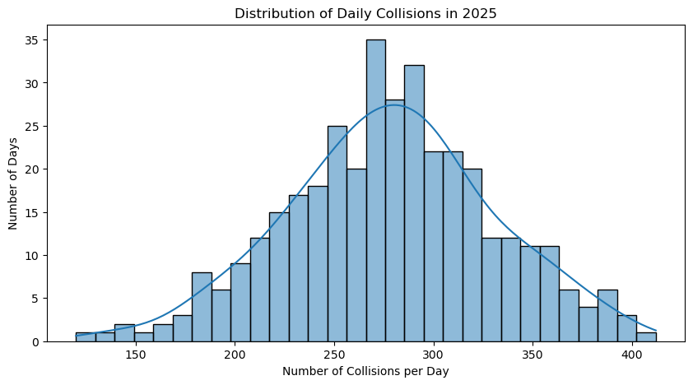
Figur 4 Observed daily counts with a KDE overly rather than a normal curve
Meam = daily_counts.meam()
Std = daily_counts.std()
Probability = 1 – norm.cdf(300.5, loc=mean, scale=std)

7. Comparison and conclusion
The distributions answer different questions, so their percentages are not competing accuracy scores. Binomial models the number of selected records meeting a binary condition; Poisson models events within a specified interval; Normal provides a continuous approximation to a roughly symmetric distribution. The original vehicle counts are strongly concentrated at small integers and are unsuitable for an unqualified Normal assumption. Aggregated national daily counts have a different shape and a different unit of observation. Increasing Binomial trials from 10 to 100 while holding p fixed changes the expected severe count from 2.62 to 26.24. The notebook generates 1,000 simulated outcomes for n = 100, producing a more symmetric shape. Here np = 26.24 and n(1-p) = 73.76, supporting Normal approximation; for n = 10, np is only 2.62. For n = 100, P(X <= 30) is 83.37% by Binomial and 83.33% by the continuity-corrected Normal approximation. The difference is about 0.04 percentage points. Increasing the number of simulated repetitions improves simulation stability, whereas increasing n changes the underlying distribution. These are separate effects. Cleveland lambda is only 1.337, so Normal approximation to that Poisson model is unsuitable: the distribution remains asymmetric and concentrated near zero. A large national mean does not solve the national Poisson variance mismatch. Overall, the analyses provide understandable summaries and conditional probabilities while showing why assumptions matter. The results describe 2025 police records, use reported severity categories, and neither establish causes nor validate predictions for future days. Further work could examine comparable weekdays and seasons before applying the models to planning. For practical interpretation, the Binomial result describes the composition of a selected group of records, while the Poisson result describes daily event frequency in one area. Neither percentage is the chance that a road user will be injured. Estimating that risk would require exposure information such as journeys or vehicle distance, together with an appropriate study design. These boundaries prevent descriptive patterns from being overstated as causal explanations.

References
The analysis uses road collision data for 2025, obtained from the Department for Transport’s Road safety open data webpage, last updated on 30 July 2026 (Department for Transport, 2026).
https://www.gov.uk/government/statistical-data-sets/road-safety-open-data
(Accessed: 29 october 2026)

